The organization that I choose to do my threat model on is The CommonWealth One Federal Credit Union. CommonWealth One Federal Credit Union was chartered in 1944, with only 94 members and an all-volunteer staff. Since then, CommonWealth One has grown to become a full-service financial institution with over 36,000 members and over $300 million in assets. They have branches located in Northern Virginia, Washington, DC and Harrisonburg, VA.
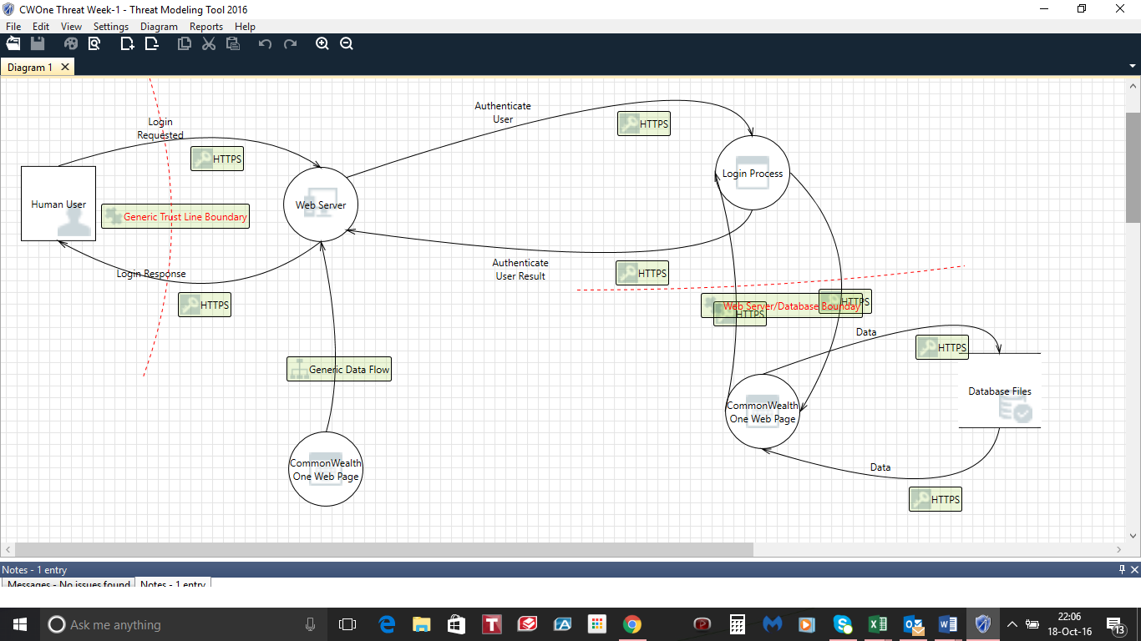

Reference
Common Wealth One Federal Credit Union. (2016). Retrieved from https://www.cofcu.org/

